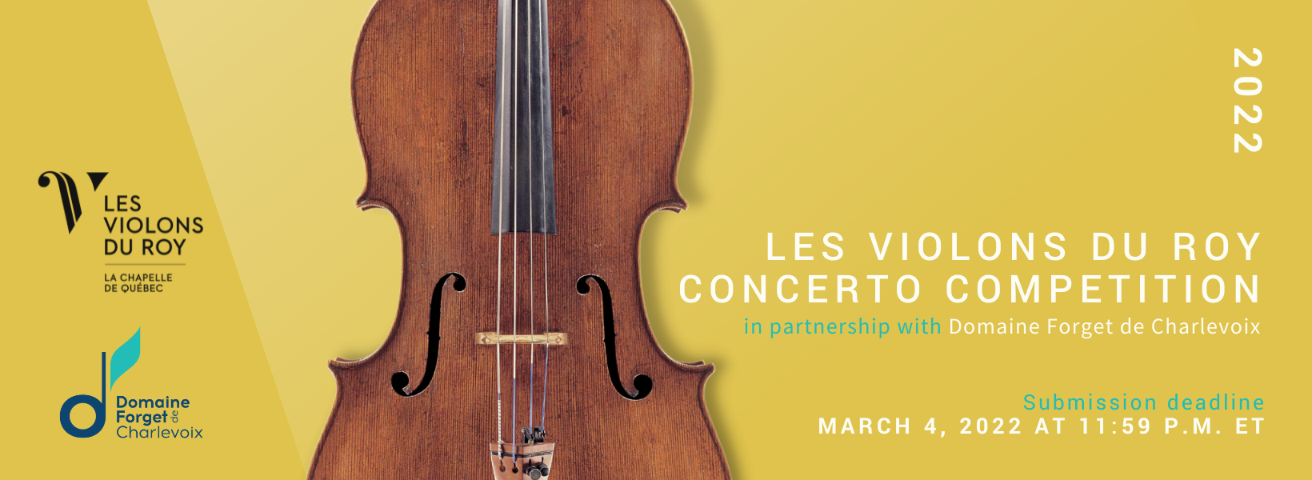
entry form

Your information
First name - Email -
Last name - Telephone -

Education
Are you a student? CHOOSE ONE
Continue only if you answered yes to the question above:

Are you a music student? CHOOSE ONE
If so, full time or part time? CHOOSE ONE
Level of music studies – CHOOSE ONE If university – CHOOSE ONE
School - Instrument instructor -

Professional experience as a musician
Do you play in a professional orchestra? – CHOOSE ONE
If so, which one(s)? -

Have you performed as a freelancer?– CHOOSE ONE
If so, with which ensemble(s)? -

Have you ever performed with Les Violons du Roy? – CHOOSE ONE
At which event? -

Social media
Do you authorize Les Violons du Roy to share your video on their social media?
– CHOOSE ONE

Do you authorize Les Violons du Roy to take pictures of you and to use them in their communications?
– CHOOSE ONE

Please email your recording, cover letter and/or video introduction, copy of identification proof, CV, and this completed form by email to mrooke@violonsduroy.com with the object “Candidature First Name, Last Name”.

The C$40 entry fee can be paid by credit card at the following link.

