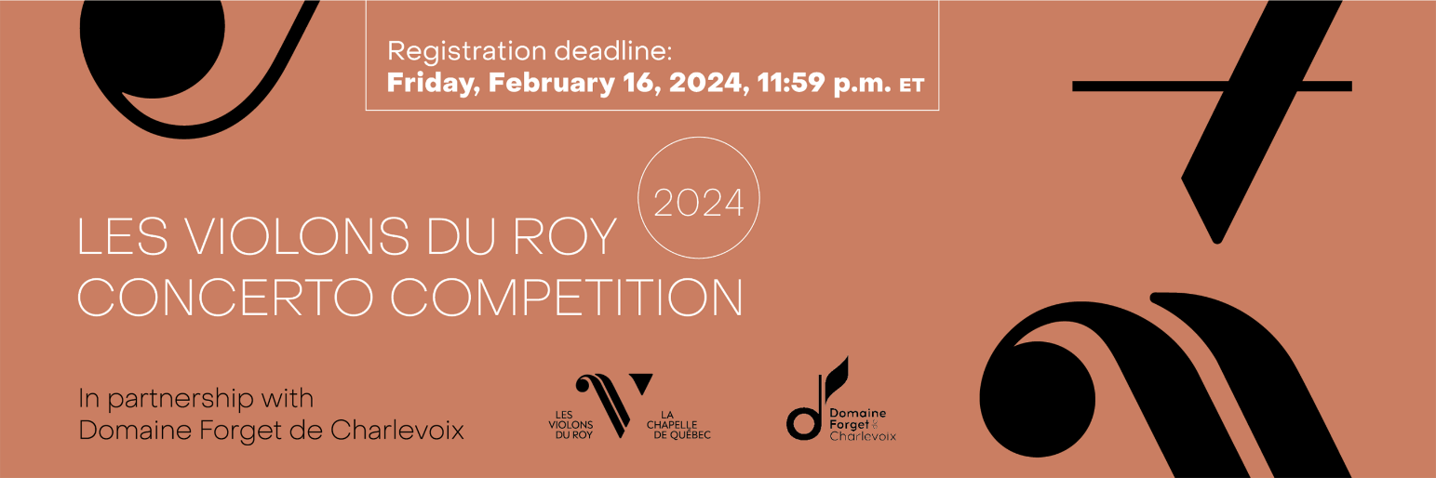

Entry Form

Personal information

First name - Email -
Last name - Telephone -
Age (on January 26, 2024) - Place of residence (city, coutry) -

Education

Are you a student? CHOISIR ÉLÉMENT

Continue only if you answered yes to the question above:

Are you a music student? CHOOSE ONE
If so, full time or part time? CHOOSE ONE
Level of music studies – CHOOSE ONE If university – CHOOSE ONE
School - Instrument instructor -

Professional experience as a musician

Do you play in a professional orchestra? – CHOOSE ONE
If so, which one(s)? -

Have you performed as a freelancer?– CHOOSE ONE
If so, with which ensemble(s)? -

Have you ever performed with Les Violons du Roy? – CHOOSE ONE
At which event? -

Authorization

For the purpose of promoting the competition and career development, we strongly invite you to allow Les Violons du Roy to share your application on its platforms.

I authorize Les Violons du Roy to share pictures of myself
I authorize Les Violons du Roy to share videos of myself, including my application video to this competition
I authorize Les Violons du Roy to communicate with me for further projets

